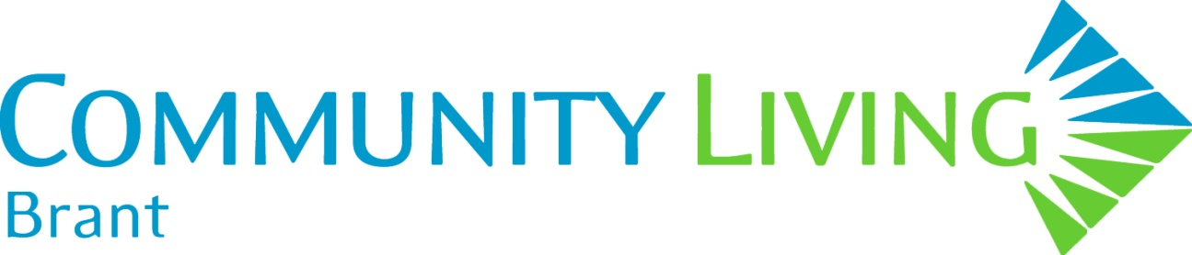
REGISTRATION FORM
BRUCE ANDERSON - We Are All Gifted: Using Gifts in Helping Professions
Monday, September 11 OR Tuesday, September 12, 2017
Northridge Golf Course, 320 Balmoral Drive, Brantford

Please print this page and submit one registration per person. Deadline is September 5, 2017
❶ REGISTRATION DATA
Name: (for name tag)
Organization:
Position/Title:
Address:
Email address:
❷ FEE AND PAYMENT | Confirm your Rate |  | Check Payment Type
$95 per person |  |  | Cheque  Payable to:  Community Living Brant
$80 per person for 3 or more from the same agency |  |  | Cash in person
❸ REGISTRATION DEADLINE DATE  AND  SUBMISSION INFORMATION | Deadline: September 5, 2017 |  | Submit completed form with payment selection to Cathy Johnson:  Email: cathyjohnson@clbrant.com  Mail: Community Living Brant  366 Dalhousie Street,  Brantford ON N3S 3W2  Fax: 519-756-7668  You will receive a Registration Confirmation by email.
❹ REFUND & SUBSTITUTION | No refunds. Substitutions can be made at any time.
❺ DATE OF ATTENDANCE:

Please Indicate Which Day You Will Be Attending
I will be attending Monday, September 11
I will be attending Tuesday, September 12

❻ DIETARY RESTRICTIONS: Please list:

